College of Health – Health & Kinesiology Learning Outcomes Assessment Plan
Program Name: BS, MS, & PhD Health & Kinesiology Program
Level: Graduate – BS, MS and PhD
Website: https://health.utah.edu/health-kinesiology/graduate-programs

BS Program with 5 emphases
- Program Overview
The B.S. in Health and Kinesiology has five emphases: Community Health Education; Emergency Medical Services; Nuclear Medicine Technology; Health and Physical Education Teaching; and Kinesiology.

Kinesiology emphasis: The kinesiology emphasis combines exercise science fundamentals along with a signature experience in community based physical activity, fitness and wellness. The emphasis is ideal for students who are interested in pursuing careers in areas such as corporate fitness, cardiac rehabilitation, and strength and conditioning. The emphasis also prepares students to pursue graduate programs in exercise science/kinesiology, physical therapy, medicine and physician assistant programs, occupational therapy, public health, and a variety of other programs that train health professionals.

Community Health Education emphasis: The community health education emphasis is a career training program that prepares students for health education roles in public, non-profit, and private health organizations including government agencies, corporate wellness facilities, and clinical education programs. This emphasis include a community health track and a workplace wellness track.

Emergency Medical Services emphasis: The emergency medical services emphasis prepares students to serve the community as an allied health professional in emergency medical response. Students choose from tracks in management, wilderness rescue, and community response/fire services.

Nuclear Medicine Technology emphasis: The nuclear medicine technology emphasis prepares students to develop the skills and knowledge required of a nuclear medicine technologist and graduates will be prepared to successfully complete the national exam in nuclear medicine technology that is required for certification and state licensure.

Health and Physical Education Teaching emphasis: The health and physical education teaching emphasis prepares student to pursue a career as a schoolteacher. Graduates from this emphasis will develop the knowledge and skill necessary to sit for certifications exams required to be a licensed teacher.

- Program Learning Outcomes:
The overall Bachelor of Science Health and Kinesiology Program Goals are:
- Demonstrate skills and knowledge related to health and kinesiology
- Apply research and/or theoretical concepts related to health and physical activity
- Demonstrate oral and written communication skills
- Evaluate and synthesize health and physical activity programming/interventions
- Demonstrate professional behavior
In addition, each emphasis has specific additional outcomes.

- Alignment Grid or Curriculum Map
The table presented below displays the assessment plan for the five emphases: Kinesiology, Community Health Education, Emergency Medical Services, Nuclear Medicine Technology, and Health and Physical Education Teaching. In the table, the learning outcomes are displayed down the left side. Along the top, the process for assessment is detailed.

Table 1: Learning Outcome Assessment for Health and Kinesiology Undergraduate Program
 | Class/experience | Exact Assessment- what will be used to assess outcome? | What criteria will be used to evaluate if outcome is achieved (letter grades, pass/fail, 1-5 scale, other)? | How many to evaluate -- randomly draw 10%? | Who is responsible for assessment? | What type of report/data is requested for the assessment?
HK UG Learning Outcomes- Kinesiology emphasis
Demonstrate skills and knowledge related to health and kinesiology | KINES 3093 | Exam | 80% above average | randomly select 10% | Weatherwax | % in each criteria
 | KINES 4301 | Lab | 80% above average | randomly select 10% | TBD | % in each criteria
 | KINES 3351 | Exam | 80% above average | randomly select 10% | Burns | % in each criteria
Apply research and/or theoretical concepts related to health and physical activity | KINES 3350 | Theories Exam | 80% above average | randomly select 10% | Stark | % in each criteria
Demonstrate oral and written communication skills | KINES 3092 | Groups Presentations | 80% above average | randomly select 10% | Groot | % in each criteria
Evaluate and synthesize health and physical activity programming/interventions | KINES 3670 | Evaluation of epidemiological studies | 80% above average | randomly select 10% | Fuller | % in each criteria
Demonstrate professional behavior | KINES 4900 | Community Program implementation | 80% above average | randomly select 10% | Lareaux | % in each criteria
 | KINES 4810 | Program implementation | 80% above average | randomly select 10% | Thompson | % in each criteria
HK UG Learning Outcomes- Community Health Education emphasis
Demonstrate skills and knowledge related to health and kinesiology | H EDU 4200 | Exams | 80% above average | randomly select 10% | Galli | % in each criteria
Apply research and/or theoretical concepts related to health and physical activity | H EDU 4250 | Application paper in which students must employ a health behavior change theory to explain a personal health behavior | 80% above average | randomly select 10% | Galli | % in each criteria
Demonstrate oral and written communication skills | H EDU 4210 | Application paper in which students will write a program plan; including a needs assessment and theory application for behavior change. | 80% above average | randomly select 10% | Lehmbeck | % in each criteria
 | H EDU 4360 | Individual presentations | 80% above average | randomly select 10% | TBD | % in each criteria
Evaluate and synthesize health and physical activity programming/interventions | H EDU 4220 | Exams, papers | 80% above average | randomly select 10% | Franklin | % in each criteria
 | H EDU 4610 | Community program implementation written report | 80% above average | randomly select 10% | Lehmbeck, Leopardi | % in each criteria
Demonstrate professional behavior | H EDU 4610 | Program implementation | 80% above average | randomly select 10% | Lehmbeck, Leopardi | % in each criteria
 | H EDU 5990 | Agency/organization project | 80% above average | randomly select 10% | Thompson | % in each criteria
 | KINES 4810 | Program implementation | 80% above average | randomly select 10% | Thompson | % in each criteria
HK UG Learning Outcomes- Emergency Medical Services emphasis
Demonstrate skills and knowledge related to health and kinesiology | H EDU 5950 | NREMT Pass Rates | Certification Cognitive Exam Pass (>75%) | 50% of majors in the class. | CEP Lead Faculty | % in each criteria
 | H EDU 5970 | NREMT Pass Rates | Certification Cognitive Exam Pass (>85%) | 50% of majors in the class. | CEP Lead Faculty | % in each criteria
 | H EDU 4950 | Class Pass Rate | Class Pass Rate (90%) | 30% of students in classes since the last evaluation. | CEP Lead Faculty | % in each criteria
Apply research and/or theoretical concepts related to health and physical activity | H EDU 4300 | Class Pass Rate | Class Pass Rate (90%) | 30% of EMS Emphasis students in the class. | CEP Lead Faculty | % in each criteria
 | H EDU 4295 | Class Pass Rate | Class Pass Rate (90%) | 30% of students in classes since the last evaluation. | CEP Lead Faculty | % in each criteria
 | H EDU 3033 | Class Pass Rate | Class Pass Rate (90%) | 30% of students in classes since the last evaluation. | CEP Lead Faculty | % in each criteria
Demonstrate oral and written communication skills | H EDU 5991 | Preceptor Evaluation | Class Pass Rate (90%) | 30% of students in classes since the last evaluation. | CEP Lead Faculty | % in each criteria
Evaluate and synthesize health and physical activity programming/interventions | H EDU 4950 | Class Pass Rate | Class Pass Rate (90%) | 30% of students in classes since the last evaluation. | CEP Lead Faculty | % in each criteria
 | H EDU 5991 | Class Pass Rate | Class Pass Rate (90%) | 30% of students in classes since the last evaluation. | CEP Lead Faculty | % in each criteria
Demonstrate professional behavior | H EDU 5991 | Preceptor Evaluation | Class Pass Rate (90%) | 30% of students in classes since the last evaluation. | CEP Lead Faculty | % in each criteria
HK UG Learning Outcomes- Nuclear Medicine Technology emphasis
Demonstrate skills and knowledge related to health and kinesiology | H EDU 3600 | Exams | 80% above average | Randomly select 10% | Casal | % in each criteria
Apply research and/or theoretical concepts related to health and physical activity | H EDU 3900 & H EDU 3820 | Lab exercises in which students must apply concepts from lecture to complete Quality Assurance in the clinic areas. | 80% above average | Randomly select 10% | Casal | % in each criteria
 | H EDU 3800 | Exams | 80% above average | Randomly select 10% | Casal | % in each criteria
 | H EDU 4000 | Exams | 80% above average | Randomly select 10% | Casal | % in each criteria
 | H EDU 4700 | Exams | 80% above average | Randomly select 10% | Casal | % in each criteria
Demonstrate oral and written communication skills | H EDU 3610 | Completion of procedure competencies and QA competencies for NMT. | Complete two from procedures category and all five from the Quality Assurance category. | Randomly select 10% | Casal | % in each criteria
 | H EDU 3810 | Completion of procedure competencies for NMT. | Complete six from procedures category. | Randomly select 10% | Casal | % in each criteria
 | H EDU 4010 | Completion of procedure competencies for NMT. | Complete twelve from procedures category. | Randomly select 10% | Casal | % in each criteria
 | H EDU 4710 | Completion of procedure and Quality Assurance competencies for CT. | Completion of twelve procedure competencies and all from quality assurance competencies categories within three months of start of CT Clinic. | Randomly select 10% | Casal | % in each criteria
Evaluate and synthesize health and physical activity programming/interventions | N/A
Demonstrate professional behavior | H EDU 3610 | Student rotation evaluation from technologist. | Score of 3/5 on each evaluation. | Randomly select 10% | Casal | % in each criteria
 | H EDU 3810 | Student rotation evaluation from technologist. | Score of 3/5 on each evaluation. | Randomly select 10% | Casal | % in each criteria
 | H EDU 4010 | Student rotation evaluation from technologist. | Score of 3/5 on each evaluation. | Randomly select 10% | Casal | % in each criteria
 | H EDU 4710 | Student rotation evaluation from technologist. | Score of 3/5 on each evaluation. | Randomly select 10% | Casal | % in each criteria
HK UG Learning Outcomes- Health and Physical Education Teaching emphasis
Demonstrate skills and knowledge related to health and kinesiology | H EDU 4230 | Exams | 80% above average | Randomly select 10% | TBD | % in each criteria
Apply research and/or theoretical concepts related to health and physical activity | KINES 3710 | Peer Teaching | 80% above average | Randomly select 10% | TBD | % in each criteria
Demonstrate oral and written communication skills | KINES 5491 | Mock Interviews | 80% above average | Randomly select 10% | TBD | % in each criteria
Evaluate and synthesize health and physical activity programming/interventions | KINES 4700 | Unit Plan | 80% above average | Include all students in major | TBD | % in each criteria
Demonstrate professional behavior | KINES 5495 | Student Teaching Evaluation | 80% above average | Include all students in major | TBD | % in each criteria

- Collection of Evaluation Evidence
As shown in Table 1 our assessment plan will begin with the courses listed in each emphasis, beginning assessment in fall 2021, as noted.
Core faculty in each emphasis identified the most suitable course/experience to assess learning within each learning outcome. In some cases, this is an exam or paper and in other cases, it is a presentation or report.

Learning will be assessed with criteria such as 80% above average in a random selection of 10% of the students. The Emergency Medical Services emphasis has slightly different criteria as noted. Each criteria will be developed by the 'instructor' (instructor of a course, preceptor, and lead faculty) of the course in which the assessment is occurring. The content of the criteria will be based on the particular learning outcome. Each criteria will be based on the above average grade. A percentage of the students in each class will be assessed, ranging from 10% to 30% of the students. The ‘instructor’ is responsible for collecting all assessment data. Once collected the data will be provided to Joanna McMinn (assistant to the DoUGs) and Anita Leopardi (DoUGs).

- Analysis of Evidence and Future Assessment Directions
Our goal for each learning outcome is for 10% to 30% of students (depending on the emphasis and class) to pass each class identified by 80% to 90%. Our goal is to improve this system each year. We feel as though we need to give the process a chance to work. After that, we will identify shortcomings each spring and work to improve it by the following fall.

- Assessment of Learning Outcomes Responsibilities
- Who writes your assessment report?
Anita Leopardi, DoUGs, anita.leopardi@health.utah.edu

- Who acts on the assessment report?
The findings from the assessment report will be shared with the ‘instructor’ in each emphasis and with the Department Chair. It is the responsibility of the DoUGs and the Department Chair to begin conversations about how best to maintain/improve the learning of their students.

MS & PhD Program
- Program Overview
The MS and PhD graduate programs are rigorous and scholarly programs which provide a broad education in the numerous subdisciplines that comprise health and kinesiology. Students can shape their education by taking advantage of a variety of specialized opportunities. Each focus area has a distinct curriculum with flexibility built in to address each student’s particular intellectual interest. The MS degree includes thesis and non-thesis options.

The program is comprised of the following degree focus areas:
- 1 non-thesis focus area (Health Education Specialist & Wellness Coaching)
- 3 research intensive MS/PhD focus areas:
1) Physical Activity and Well Being
2) Exercise and Disease
3) Cognitive and Motor Neuroscience

- Program Learning Outcomes:
The graduate program has the following learning outcomes:
- Describe core concepts and theories in your field of study.
- Acquire, evaluate, and synthesize state of the science in your area of study.
- Communicate clearly and concisely to diverse audiences in oral and written forms.
- Participate in professional development opportunities.
- Demonstrate the acquisition of knowledge and understanding in your area of study through a culminating experience.

- Alignment Grid or Curriculum Maps
Two tables are presented below. Table 1 displays the assessment plan for the research-intensive MS and PhD focus areas. Table 2 provides the assessment plan for the MS non-thesis focus area. In the tables below the learning outcomes are displayed down the left side. Along the top the process for assessment is detailed. Because the H&K research-intensive graduate program has 3 focus areas the table is color-coded. The Cognitive and Motor Neuroscience focus area is in blue, the Exercise and Disease focus area is in orange and the Physical Activity and Well-Being focus area is in green. Cross focus area experiences are highlighted in yellow.

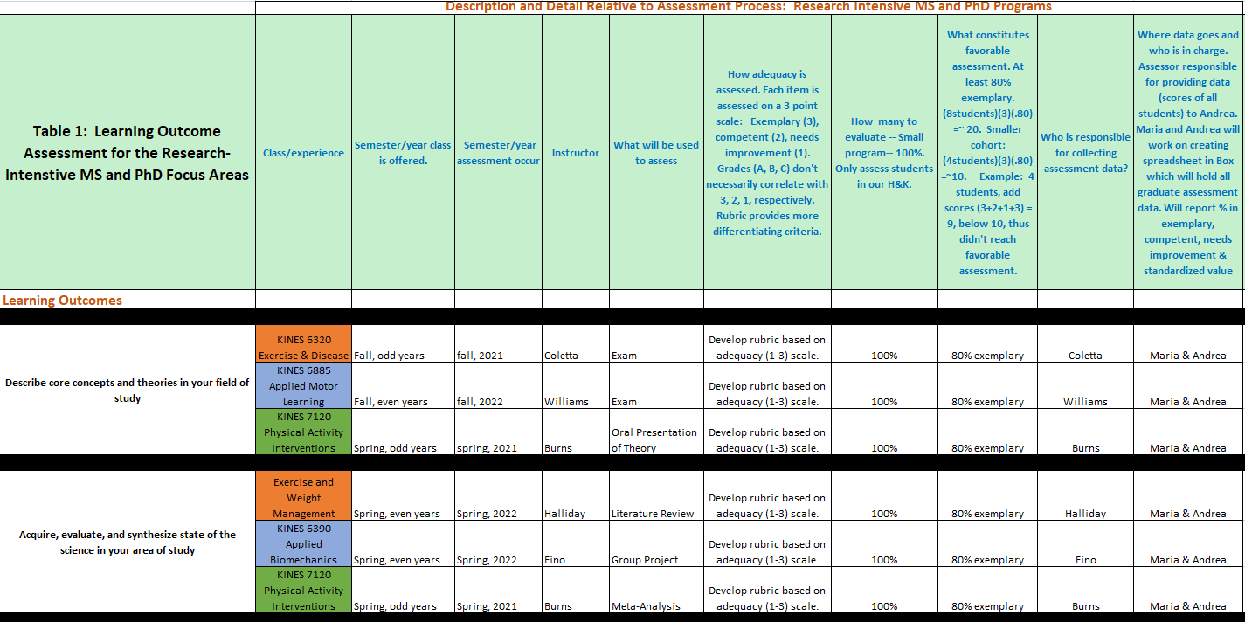

Table 1, con’t.
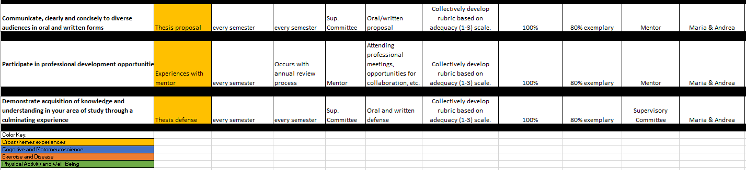

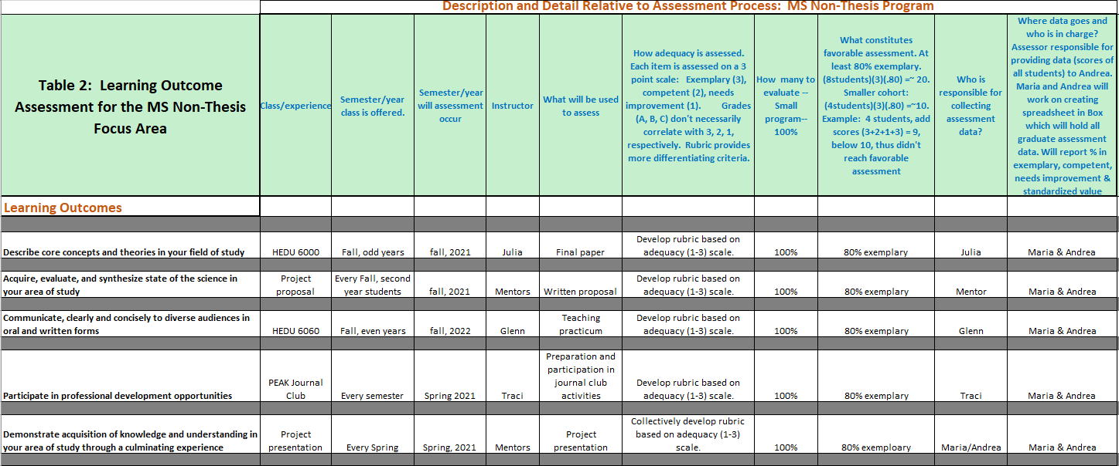

- Collection of Evaluation Evidence

As shown in Tables 1 and 2 our assessment plan will begin with the following courses/experiences in Spring, 2021:
- Research-intensive MS/PhD, Spring, 2021: KINES 7120, thesis proposal, Experiences with Mentor, and thesis defense.
- MS non-thesis, Spring, 2021: PEAK Journal Club, project presentation

Core faculty in each degree program and focus area identified the most suitable course/experience to assess learning within each learning outcome. In some cases, this is an exam or paper and in other cases it is a proposal or the collection of meetings a student has with their mentor. The tables highlight that every learning outcome will be assessed in the four focus areas. Because courses are not taught every year it will take 2-3 years to fully assess learning in the program.

Learning will be assessed with a rubric. The rubrics will begin to be developed in Spring, 2021. Each rubric will be developed by the ‘instructor’ (instructor of a course, mentor, supervisory committee) of the course in which the assessment is occurring. The content of the rubric will be based on the particular learning outcome. Each rubric will employ a 3-point grading system: 3 = exemplary, 2 = adequate, 1 = needs improvement. For example, Table 1 shows that the learning outcome of “Participate in professional development opportunities” is assessed during students’ experiences with their mentor. All mentors assess their students in terms of attending meetings, collaborating, etc. on a 3-point scale with a rubric. In this case one single rubric collectively developed by the mentors will be used.

All H&K students will be assessed. The ‘instructor’ is responsible for collecting all assessment data. Once collected the data will be provided to Andrea and Maria (Program Manager and DoGs).

- Analysis of Evidence and Future Assessment Directions
Our goal for each learning outcome is for 80% of students to achieve an exemplary level. The raw data (a value of 1, 2, or 3 on the rubric) for each student will be input into a database. To determine the minimum value to achieve our assessment goal of 80% exemplary the following calculation will be made for each assessment: (n students)(3)(.80). Following the example above, suppose 12 students were assessed in relation to the learning outcome of “Participate in professional development opportunities” Using the formula above, (12 students)(3)(.80) = 28.8. The rubric scores of the 12 students are summed. For example, 2+1+3+3+2+2+1+3+3+3+2+2 = 27. 27 < 28 and thus the assessment in this case did not reach our goal of 80% exemplary. In this case the rubrics of each student will be analyzed to determine consistent areas in which the assessments were not ideal. This information will be relayed back to the instructor.
Our goal is try to improve our system each year. We feel as though we need to give the process a chance to work. After that we will identify shortcomings each spring and work to improve it by the following fall. A possible shortcoming is the lack of a detail being relayed back to the instructor so that they can improve their pedagogy.

- Assessment of Learning Outcomes Responsibilities
- Who writes your assessment report?
Maria Newton, DoGs, maria.newton@health.utah.edu
- Who acts on the assessment report?
The findings from the assessment report will be shared with the ‘instructor’ as well each focus area. It is the responsibility of each focus area to begin conversations about how best to maintain/improve the learning of their students.

