College of Health – Health & Kinesiology Learning Outcomes Assessment Plan
Program Name: MS: Health & Kinesiology Program
Level: Graduate – MS and PhD
Website: https://health.utah.edu/health-kinesiology/graduate-programs

- Program Overview
The MS and PhD graduate programs are rigorous and scholarly programs which provide a broad education in the numerous subdisciplines that comprise health and kinesiology. Students can shape their education by taking advantage of a variety of specialized opportunities. Each focus area has a distinct curriculum with flexibility built in to address each student’s particular intellectual interest. The MS degree includes thesis and non-thesis options.

The program is comprised of the following degree focus areas:
- 1 non-thesis focus area (Health Education Specialist & Wellness Coaching)
- 3 research intensive MS/PhD focus areas:
1) Physical Activity and Well Being
2) Exercise and Disease
3) Cognitive and Motor Neuroscience

- Program Learning Outcomes:
The graduate program has the following learning outcomes:
- Describe core concepts and theories in your field of study.
- Acquire, evaluate, and synthesize state of the science in your area of study.
- Communicate clearly and concisely to diverse audiences in oral and written forms.
- Participate in professional development opportunities.
- Demonstrate the acquisition of knowledge and understanding in your area of study through a culminating experience.

- Alignment Grid or Curriculum Maps
Two tables are presented below. Table 1 displays the assessment plan for the research-intensive MS and PhD focus areas. Table 2 provides the assessment plan for the MS non-thesis focus area. In the tables below the learning outcomes are displayed down the left side. Along the top the process for assessment is detailed. Because the H&K research-intensive graduate program has 3 focus areas the table is color-coded. The Cognitive and Motor Neuroscience focus area is in blue, the Exercise and Disease focus area is in orange and the Physical Activity and Well-Being focus area is in green. Cross focus area experiences are highlighted in yellow.

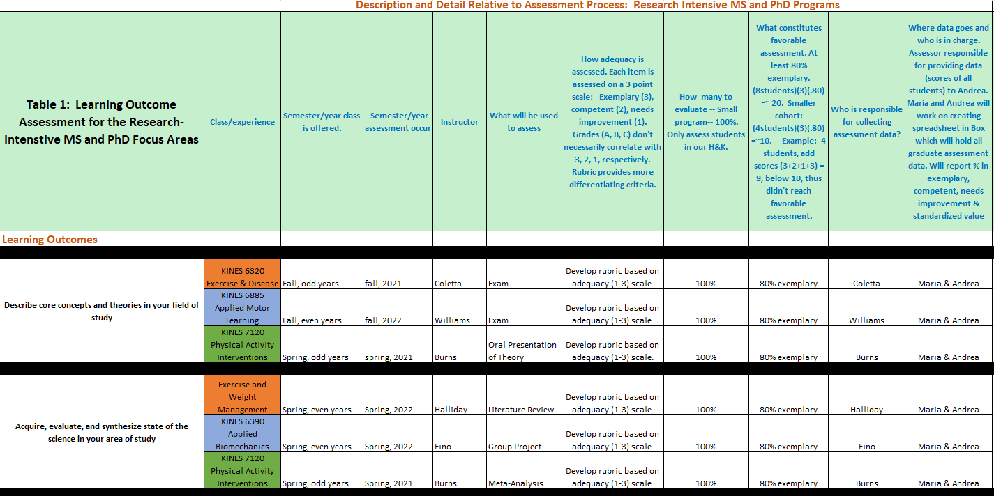

Table 1, con’t.
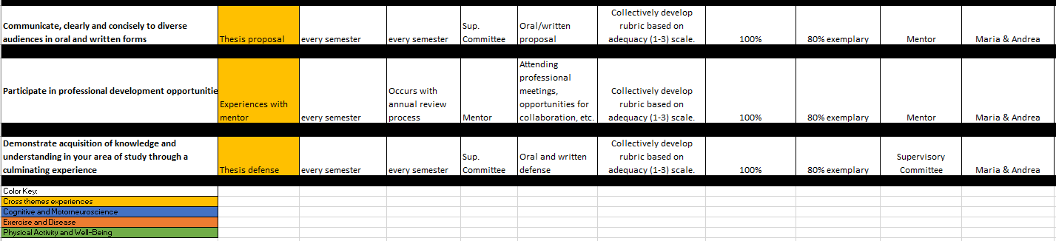

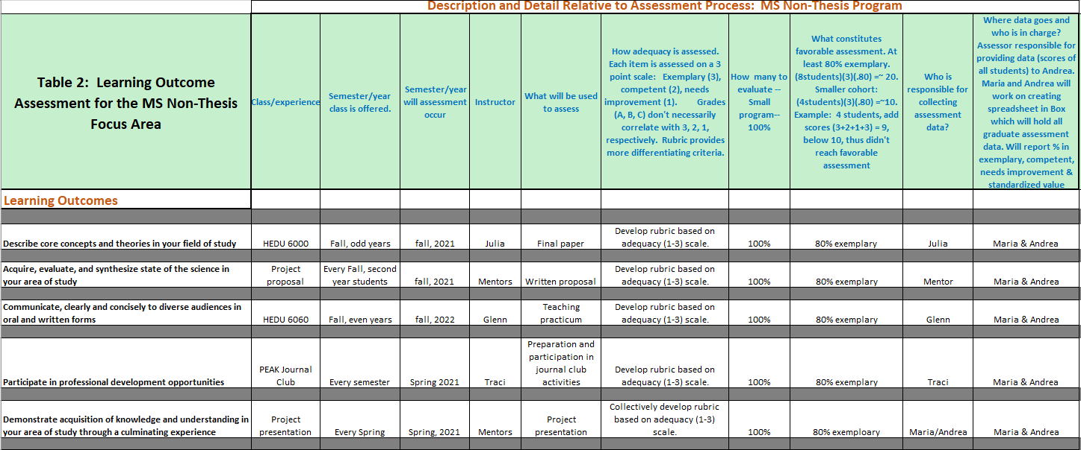
- Collection of Evaluation Evidence

As shown in Tables 1 and 2 our assessment plan will begin with the following courses/experiences in Spring, 2021:
- Research-intensive MS/PhD, Spring, 2021: KINES 7120, thesis proposal, Experiences with Mentor, and thesis defense.
- MS non-thesis, Spring, 2021: PEAK Journal Club, project presentation

Core faculty in each degree program and focus area identified the most suitable course/experience to assess learning within each learning outcome. In some cases, this is an exam or paper and in other cases it is a proposal or the collection of meetings a student has with their mentor. The tables highlight that every learning outcome will be assessed in the four focus areas. Because courses are not taught every year it will take 2-3 years to fully assess learning in the program.

Learning will be assessed with a rubric. The rubrics will begin to be developed in Spring, 2021. Each rubric will be developed by the ‘instructor’ (instructor of a course, mentor, supervisory committee) of the course in which the assessment is occurring. The content of the rubric will be based on the particular learning outcome. Each rubric will employ a 3-point grading system: 3 = exemplary, 2 = adequate, 1 = needs improvement. For example, Table 1 shows that the learning outcome of “Participate in professional development opportunities” is assessed during students’ experiences with their mentor. All mentors assess their students in terms of attending meetings, collaborating, etc. on a 3-point scale with a rubric. In this case one single rubric collectively developed by the mentors will be used.

All H&K students will be assessed. The ‘instructor’ is responsible for collecting all assessment data. Once collected the data will be provided to Andrea and Maria (Program Manager and DoGs).

- Analysis of Evidence and Future Assessment Directions
Our goal for each learning outcome is for 80% of students to achieve an exemplary level. The raw data (a value of 1, 2, or 3 on the rubric) for each student will be input into a database. To determine the minimum value to achieve our assessment goal of 80% exemplary the following calculation will be made for each assessment: (n students)(3)(.80). Following the example above, suppose 12 students were assessed in relation to the learning outcome of “Participate in professional development opportunities” Using the formula above, (12 students)(3)(.80) = 28.8. The rubric scores of the 12 students are summed. For example, 2+1+3+3+2+2+1+3+3+3+2+2 = 27. 27 < 28 and thus the assessment in this case did not reach our goal of 80% exemplary. In this case the rubrics of each student will be analyzed to determine consistent areas in which the assessments were not ideal. This information will be relayed back to the instructor.
Our goal is try to improve our system each year. We feel as though we need to give the process a chance to work. After that we will identify shortcomings each spring and work to improve it by the following fall. A possible shortcoming is the lack of a detail being relayed back to the instructor so that they can improve their pedagogy.

- Assessment of Learning Outcomes Responsibilities
- Who writes your assessment report?
Maria Newton, DoGs, maria.newton@health.utah.edu
- Who acts on the assessment report?
The findings from the assessment report will be shared with the ‘instructor’ as well each focus area. It is the responsibility of each focus area to begin conversations about how best to maintain/improve the learning of their students.

