Deeply Engaged Learning Experiences
An Undergraduate Studies Portfolio
2019-20 Annual Report

This document summarizes the activity of the Deeply Engaged Learning Experiences (DELE) portfolio group in Undergraduate Studies during the 2019-20 academic year. The document summarizes the work that has been done to generate data to assess the portfolio’s goals, it describes the results, and discusses the DELE portfolio’s plans for the upcoming year.

Background
Deeply Engaged Learning Experiences are one of a set of high impact practices in higher education that have been shown to contribute significantly to keeping students in college and helping them be successful. Below is a brief discussion of high impact practices to help identify where deeply engaged learning experiences belong in this context.

What are High Impact Educational Practices?
The American Association of Colleges and Universities (AACU) has recently published the following list of High Impact Practices (HIPs):

- First-year Seminars and Experiences
- Common Intellectual Experiences
- Learning Communities
- Writing-intensive Courses
- Collaborative Assignments and Projects
- Undergraduate Research
- Diversity and Global Learning
- Service Learning, Community-based Learning
- Internships
- Capstone Courses and Projects

As previous reports have discussed, at the University of Utah, high impact practices fall into three big categories: (1) Learning Communities; (2) Bachelor Degree requirements (the International, Diversity, and the Upper Division Writing (CW) Requirements; and (3) Deeply Engaged Learning Experiences, which include internships, community-based learning, Learning Abroad, the MUSE Project, Undergraduate Research and Capstone Projects.

What are Deeply Engaged Learning Experiences?
Students practice deeply engaged learning when they devote themselves to a purposeful
educational experience that goes beyond standard curricular requirements and enables them to develop their capacities for inquiry and analysis, creativity, and constructive action. The University of Utah makes these experiences available to every student through programs that offer sustained interaction with faculty or staff, deep inquiry into a specific discipline, and engagement with multiple modes of learning.

Deeply Engaged Learning Experiences at the University of Utah
The DELE portfolio has membership from organizations across the university and is open to new organizations whenever they are discovered. Currently the membership includes representatives from:

- The Bennion Center (Community-based research, community-engaged learning)
- Capstone Programs
- Career Services (Internships)
- Hinckley Institute (Internships)
- Honors College (Honors Praxis Labs, Honors Thesis)
- Learning Abroad
- My “U” Signature Experience (MUSE)
- Office of Undergraduate Research (Undergraduate Research Opportunity Program (UROP), Undergraduate Research Scholar Designation (URSD), and the Summer Program for Undergraduate Research (SPUR)

The DELEs offered by these organizations also help advance the goals of the University’s signature Exceptional Educational Experience (E3)—especially in providing experiences outside of the traditional classroom where students get the opportunity to broaden the range and depth of their educational experiences in their disciplines.

Assessment Plan
The DELE assessment plan below describes the three big goals of the DELE portfolio group as well as the strategies/tactics and metrics we are using to assess their accomplishment.

 | STRATEGIES/TACTICS | MEASUREMENT/METRIC | ASSESSMENT NOTES
DEEPLY ENGAGED LEARNING PORTFOLIO
DELE Goal 1: Assess the status of DELEs on campus | Optimize resources and collaboration among programs offering DELEs | Establish greater community and collaboration among major providers of DELE opportunities on our campus. The DELE Portfolio team has expanded to include several campus partners, including: the Hinckley Institute, Learning Abroad, and Career Services.
 | Establish an exhaustive inventory of DELEs | The DELE Portfolio team is developing an inventory that will allow us to track DELEs and participation in DELEs across campus | This has been completed.
 | Track student involvement in DELEs | Participation data collection project currently underway; data due from units in August 2019 Goal is to get # of unique students | This was completed. We have unids of all students in all DELE programs at the University through Spring 2019 semester.
 |  | We will partner with OBIA to employ Civitas to assess the impact of these programs | We have done Illume Impact studies, which examine the relationship of program participation on psersistence, for all of our programs and presented it to the UGS Administrator's team.
DELE Goal 2: Develop a systematic approach to assessing the student learning that occurs in the context of deeply engaged learning experiences
 | Promote the alignment of DELE providers’ learning outcomes with the DELE learning outcomes listed above | Collect learning outcomes of units represented on the DELE Portfolio team | We asked DELE program directors whether their programs met at least one of the DELE learning outcomes as we have them defined for this portfolio.
 | Assess student participants’ achievement of learning outcomes | Combine qualitative and quantitative measures to assess the numbers of students participating, what we hope they will learn, what they think they are learning, and how this represents an undergraduate education at the U | We are working on this and discussing how we measure outcomes in programs and in DELE. We are going to start with a survey,
 | Plan for how data will be used to inform change | Collect learning outcomes of units represented on the DELE Portfolio team | Our survey will allow us to do this.
DELE Goal 3: Increase participation in DELEs, especially by students from underrepresented communities |  |  | After updating our data to include program participation through Summer 2020 we want to examine the ethnic distribution of enrollment in DELEs and use that information to develop strategies for increasing enrollment.
 | Increase the number and variety of DELE opportunities and increase student participation in DELEs | Engage faculty more effectively to build these opportunities and to help get more students involved.
 |  | Find ways to fill the “unused capacity” of existing DELE programs—recruiting students into available places not currently being filled.
 |  | Develop more extensive reporting by students of their positive experiences in these programs—more peer-to-peer communication and marketing.

Summary of Activities and Findings: 2019-20
During the 2019-20 academic year, the DELE portfolio group focused on collecting the Unids of students participating in our programs over the past three years so we could use that information for studying the impact of our programs. Specifically, we worked with OBIA to conduct a number of studies using the Civitas Impact module. This module takes a set of students that the user defines (usually by membership in a program) and calculates the improved persistence (retention to the semester or graduation) of students in that program compared to other matched students at the University. The matching group is created such that their likelihood of persisting is the same as those students in the program by matching them on a large of set of demographic and university-specific variables. Then, if there is a difference in persistence between the groups the semester after participation in the program, it can be argued that that differences is the result of participation in the program.

Overall DELE Persistence Study Results
The first study utilized all of the Unids we had accumulated from all of our programs from 2016-2019. That study found that
- Participating in one deeply engaged learning experience in the fall led to a significant 1.6% increase in persistence to the spring semester over the matched comparison group
- The increase in persistence for students in 2, or 2 or more DELE programs was 1.7% and 1.5%, respectively, but these increases were not statistically significant
- Participation in programs in the spring did not lead to increased persistence in the fall.
Detailed Analysis of Persistence by Demographic and Other Characteristics
We asked for and got a detailed analysis of the particular groups and characteristics of students who had greater persistence compared to others. The following characteristics were associated with the statistically significant lift in persistence listed below:
- Having completed four or more semesters (1.64%) but not 0 semesters (not significant - n.s.) or 1-3 semesters, (n.s.)
- Participating in all in-person classes (2.18%) but not a mix of online and in person (n.s.)
- Being a part-time student (6.70%) but not a full-time student (n.s.)
- Being in a non-STEM field (2.42%) but not in STEM (n.s.).

Follow-up Analysis Request for Separate Programs
The overall finding of 1.6% lift led us to ask the next logical question: are there particular programs that are more responsible for the lift in persistence than others? We asked this question in the interest of better understanding what kinds of experiences might be more associated with persistence so those programs could be studied and elements of them replicated to help increase persistence for others.

This request to OBIA resulted in 13 separate Impact Analyses – one for each of the distinct programs in the seven organizations that are represented on the DELE portfolio team. This resulted in the finding that there were only two programs that experienced statistically significant persistence lifts according to Civitas: Honors Thesis students (4.4%) and the Office of Undergraduate Research – Undergraduate Research Scholar Designation (URSD) students (4.3%).

Once again, we requested detailed analyses of these findings. This revealed significant findings that were similar to the findings for the group as a whole. One that is worth mentioning in particular is related to the impact of both programs on part-time students. Both Honors (8.7%) and URSD (8.2%) students who were part-time received statistically significant and meaningful increases in persistence as the result of participation in these programs. Full time students in both Honors (3.4%) and URSD (2.5%) also received lifts in persistence that were significant, but the magnitude of the part-time lifts for both programs is worth noting.

Plans for 2020-21

Our plans for 2020-21 have evolved over the past couple of months as we recognize the extraordinary toll that the COVID-19 pandemic is having on our colleagues and students at the University. Everyone is working particularly hard and mostly in isolation and we are hesitant to add to that burden.

We originally intended to send out a request to the directors of the DELEs in our portfolio and ask them to once again supply us with the Unids of students participating in their programs so we could examine the students’ persistence. In conversations with each other we realized that this kind of analysis is possible to do in retrospect by collecting the identifying information from these programs after the fact, so we are planning to do this next year. We also believe there isn’t a huge need to do this kind of analysis again just one year after the original study. We don’t think the information will change significantly. We also realize that the pandemic has impacted both participation in programs as well as their execution, so it is unlikely to be a representative year. It may be illuminating to look at any potential differential effect that DELEs have on student persistence, but this will need to wait until next year.

We do, however, want to reflect on the work of this portfolio group, which, along with the other UGS portfolios, is approaching a term of ten years since inception in 2011. We feel as though the pandemic-induced pause in our work and regular way of doing business provides us with an opportunity to step back and take a look at what we have accomplished and what goals we might want to have as we move forward into the next decade.

The DELE group has defined deeply engaged learning experiences and has engaged programs on campus in conversations and data gathering to understand patterns of participation as well as the degree to which these programs meet the DELE outcomes. We have also collected student level ID’s so we can run Illume Impact studies and understand the impact of these programs on retention and persistence to graduation as described in this report. We have found that we have a small (1.6%) but significant impact on persistence overall.

This significant effect occurred among 1,459 students who participated in fall programs from 2016-2019. Our analysis examined their persistence to spring. If 1.6% more students in a DELE program persisted (and we assume their participation in a DELE had something to do with their persistence) then this means 1459 * .016 = 23 more students remained (or persisted to graduation) who participated in a DELE compared to the 1459 matched students who did not participate in a DELE. This is a very meaningful result when it is considered in terms of the impact that continuing in or completing school can have on an individual. It is also worth noting that it is a lot more cost effective to keep one student than it is to recruit another one, so there are cost-benefit implications to these findings as well.

As mentioned earlier, participating in a DELE also is associated with a very meaningful and significant 6.7% increase in persistence for part-time students. There were 181 students in the analyzed group, which means 12 more part-time students persisted who were in DELEs compared to those who weren’t. Again, these findings are powerful when the personal circumstances of students and the cost implications are considered.

Table 1: Civitas Impact Study Results: First-Year Learning Communities and Deeply-Engaged Learning Experiences 2016-19.

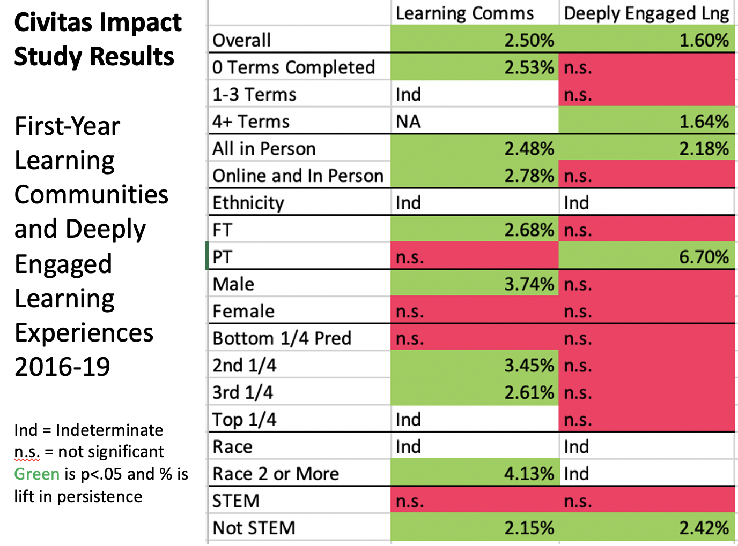

But, the data we generated were not able to show similar effects for students from historically underrepresented populations (see Table 1). This was, in large part, a function of the number of students in these programs. For example, three out of the seven race categories of students in DELEs had fewer than 30 students in them, which led us to say that the findings for that analysis were “indeterminate.” Two of the racial categories had boosts in persistence that were actually higher than white students, but those boosts were not significant because of the very low sample sizes and higher variation in those groups. In other words, the participation in these programs is not diverse enough to show whether those in the diverse groups are experiencing a significant boost. There just isn’t enough statistical power.

Similarly, the 219 Hispanic students in the analysis showed a nonsignificant boost of 1.74% compared to the significant 1.62% boost for the 1,239 non-Hispanic students. This tells us that there is a lot of variability in the effect that these programs have on Hispanic students, but if we figure out how to have a consistent effect, it will likely lead to a significant boost in persistence.

Recommendations
Here are some recommendations based on the findings from our persistence study.

1. If we look at the whole table above, including Learning Communities, we see that there is an association between participation in deeply engaged learning experiences and persistence for students who are in their 4th term or later, are taking courses entirely in person, are part time, or are non-STEM students. Learning Communities are serving students in their first semester (0 Semesters Completed). Students who have completed 1 to 3 semesters (sophomores) do not see any persistence benefit from DELEs or Learning Communities, so this may be somewhere that we can have an impact.

2. DELEs do not seem to be having a persistence impact on students who are in both online and in-person classes. It might make sense to talk with our own membership and others about developing DELEs for students who are online, because, of course, most students are online during the pandemic and we only expect our online profile to increase as we move forward. It might make sense for us to better understand the aspects of learning communities that are contributing to their impact with students who are taking online and in-person classes, because those learning community students are experiencing a boost in persistence.

3. The DELE Group plans to continue to collect data from the University of Utah offices that offer these experiences. As before, we’ll work to identify students through UNIDs and encourage all DELE programs to do this as well. A particular focus for this collection will be to assess whether these programs are contributing to retention in the context of the pandemic.

4. We talked at our last meeting about the value of being able to survey students two or three years after their graduation. We think that this postgraduate perspective might enable students to evaluate their experience with deeply engaged learning at the U in quite powerful ways. They will presumably have a greater sense of how specific DELEs have had an empowering effect on their postgraduate lives, including their further educational and professional experience.

A practical challenge facing this effort will be getting in touch with students after they’ve left the University. We intend to explore the possibility of using student email addresses based on their UNIDs in the hope that these might remain active for a considerable time after graduation.

